
Mathematics Department

11 Maths Methods Test 6 Even

Introduction to Differentiation
Name
Section 1 – Resource Free – Students can have the formula sheet
Marks : 31 Time: 33 minutes (maximum)

1: [2, 2, 2, 2, 3, 2 = 13 marks]

Differentiate each of the following with respect to ‘x’.
Write answers with positive indices and do obvious simplification

a) y = x⁵ + 4x² – 8x + 3 b) g(x) =

c) f(x) = (8 – x)(5x² + 7) d) y = (3 – 5x)²

e) y = f) y =

2: [2 marks]

State one function whose derivative is 2x – 1.

3. [4 marks]

Find the equation of the tangent line to the curve y = 2x³ – x² + 6
at the point (-1,3).

4. [2, 1, 1, 2 = 6 marks]

Given y = (2x + 1)² and u = 2x + 1, find:

a)

b)

c) y in terms of u.

d) in terms of x

5. [5 marks]

Below is a graph of y = f(x)

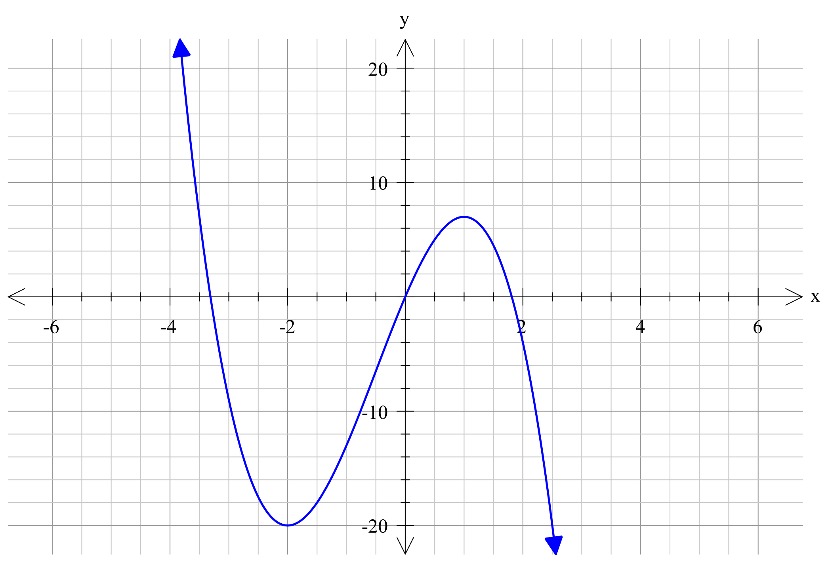
a) State the value(s) of x for which:

i) f ‘ (x) < 0

ii) f ‘ (x) = 0

iii) f ‘ (x) > 0

b) On the grid above, draw a possible graph of y = f ‘ (x)

6. [2 marks]
Below is a graph of y = g ‘ (x)
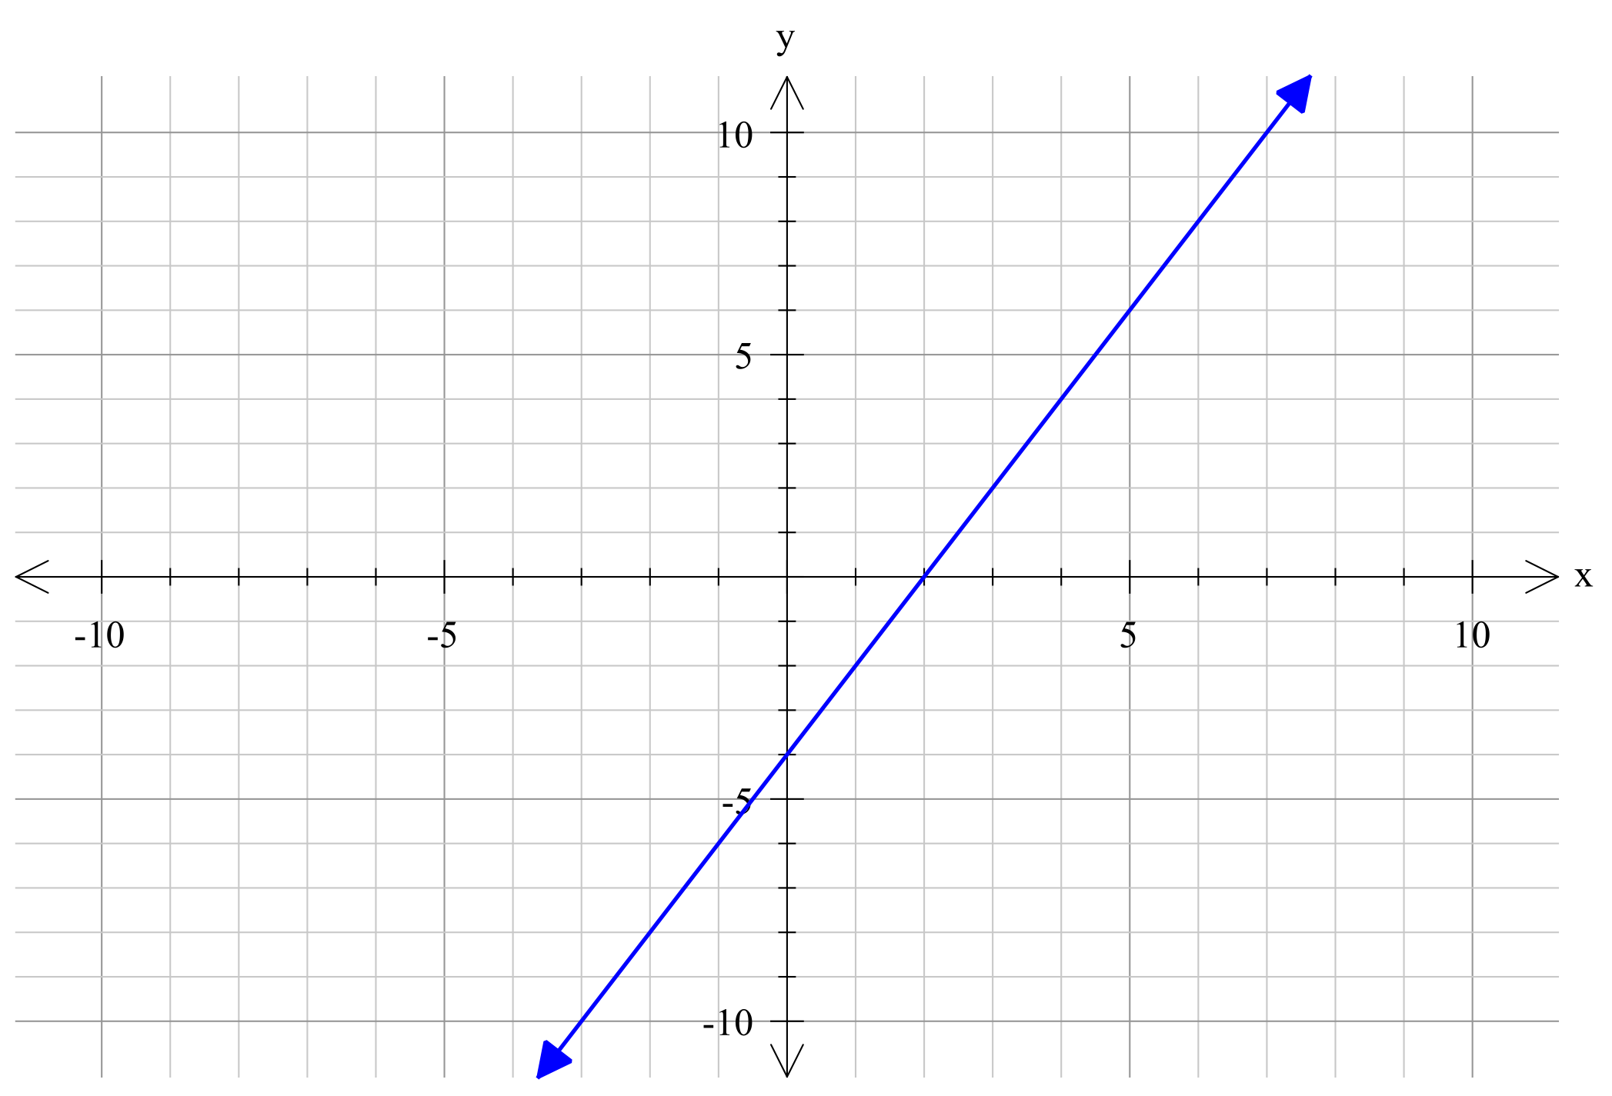

On the grid above, draw a possible graph of y = g(x)


Mathematics Department

11 Maths Methods Test 6 Odd

Introduction to Differentiation
Name
Section 2 – Resource Rich – calculators, formula sheet and 1 page of notes
Marks : 25 Time: 27 minutes (minimum)

1. [5, 2 = 7 marks]
a) Given the function f(x) = 5x³, complete the following table:

Point P | Point Q | Gradient of PQ (3 decimal places)
(2, 40) | (3, 135)
(2, 40) | (2.1, )
(2, 40) | (2.01, )
(2, 40) | (2.001, )

b) Find the value of the gradient to the curve f(x) = 5x³, at the point (2, 40)

2. [4 marks]
Given f(x) = 6x – 3, find:

a) f(x + h)

b) Show that

3. [1, 3 = 4 marks]
Given that f(t) = 4t³ – 2t, find:

a) f ‘ (t)

b) Hence, or otherwise, find when f ‘ (t) = 1

4. [5 marks]
Find the point(s) of intersection between the curves y = x² + 2x + 3 and y = x² - x + 6. Hence, find the equation of the tangent(s) to the curve y = x² - x + 6 at the point(s) of intersection.

5. [5 marks]

y = 2x + 1 is a tangent to the curve y = ax³ + bx, at the point (1, 3). Find the values of a and b.

